**OBSERVATIONAL QUESTIONS**

**Small Telescope**

In this round you are going to observe the Moon using the telescope you made. Set up your telescope in the table provided for you. Beside this question paper, you must get a map of the moon and an aswer sheet. Please write or draw the answer of these questions in the answer sheet.

1. Point your telescope to the moon, sketch termination line of the moon on the chart given. (30 points)
2. Write down the cardinal directions in the chart (N,S,E,W) (30 points)
3. Mark the position of the south pole of the moon. (20 points)
4. Mark the position of the famous Tycho crater. (20 points)

**OBSERVATIONAL SOLUTION**

1. Termination line inside the white area : Full Score

Termination line crosses the white area : Half Score

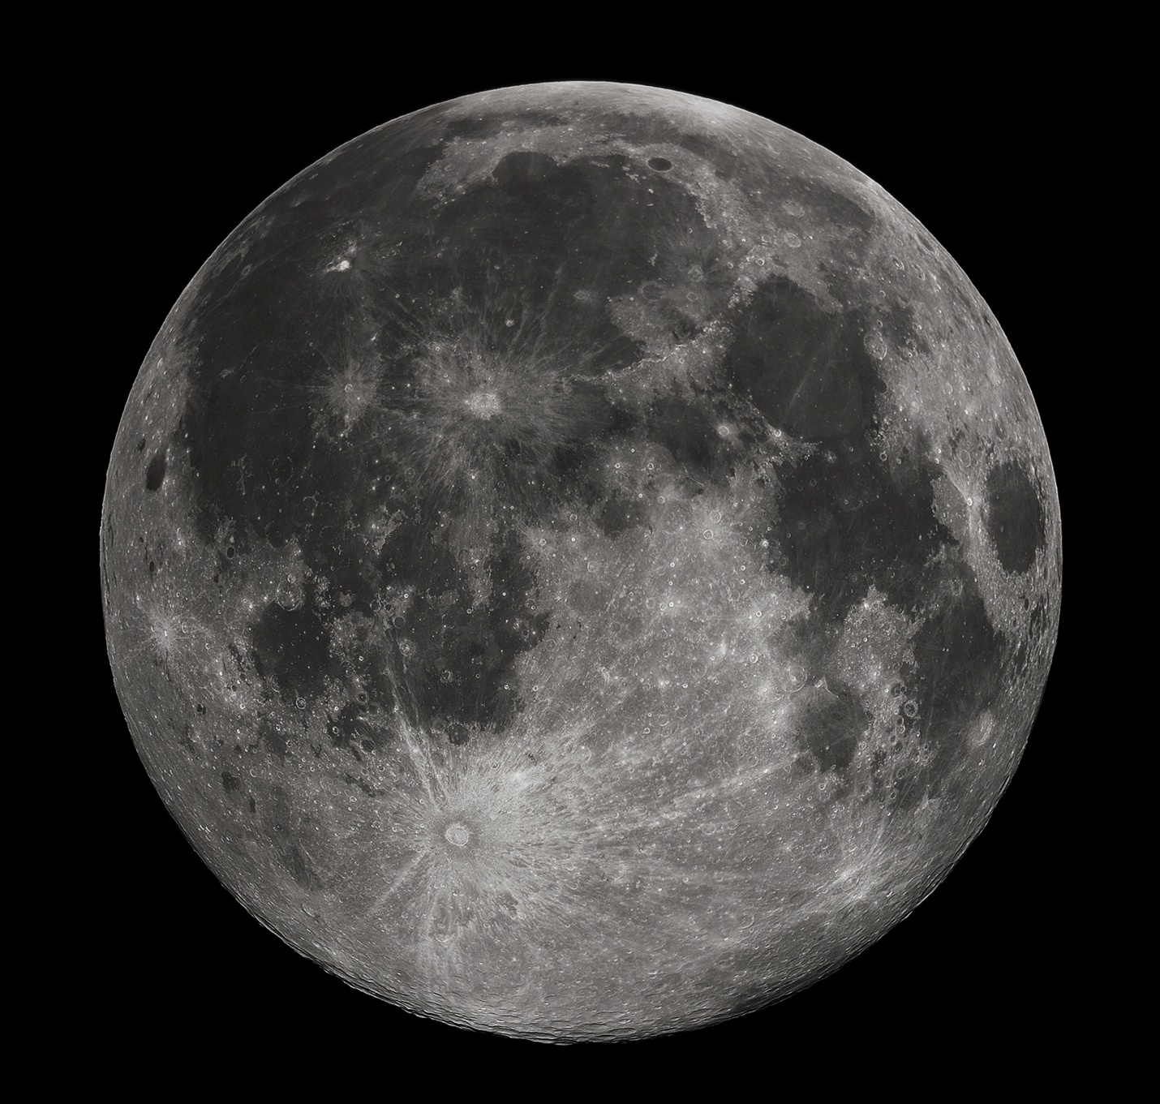



E

W

S



1. Cardinal Points (Inside the white line, Full Score)
2. South Pole (Smallest Circle, Full Score; Medium Circle, Half Score; Largest Circle, Quarter Score)
3. Tycho Crater

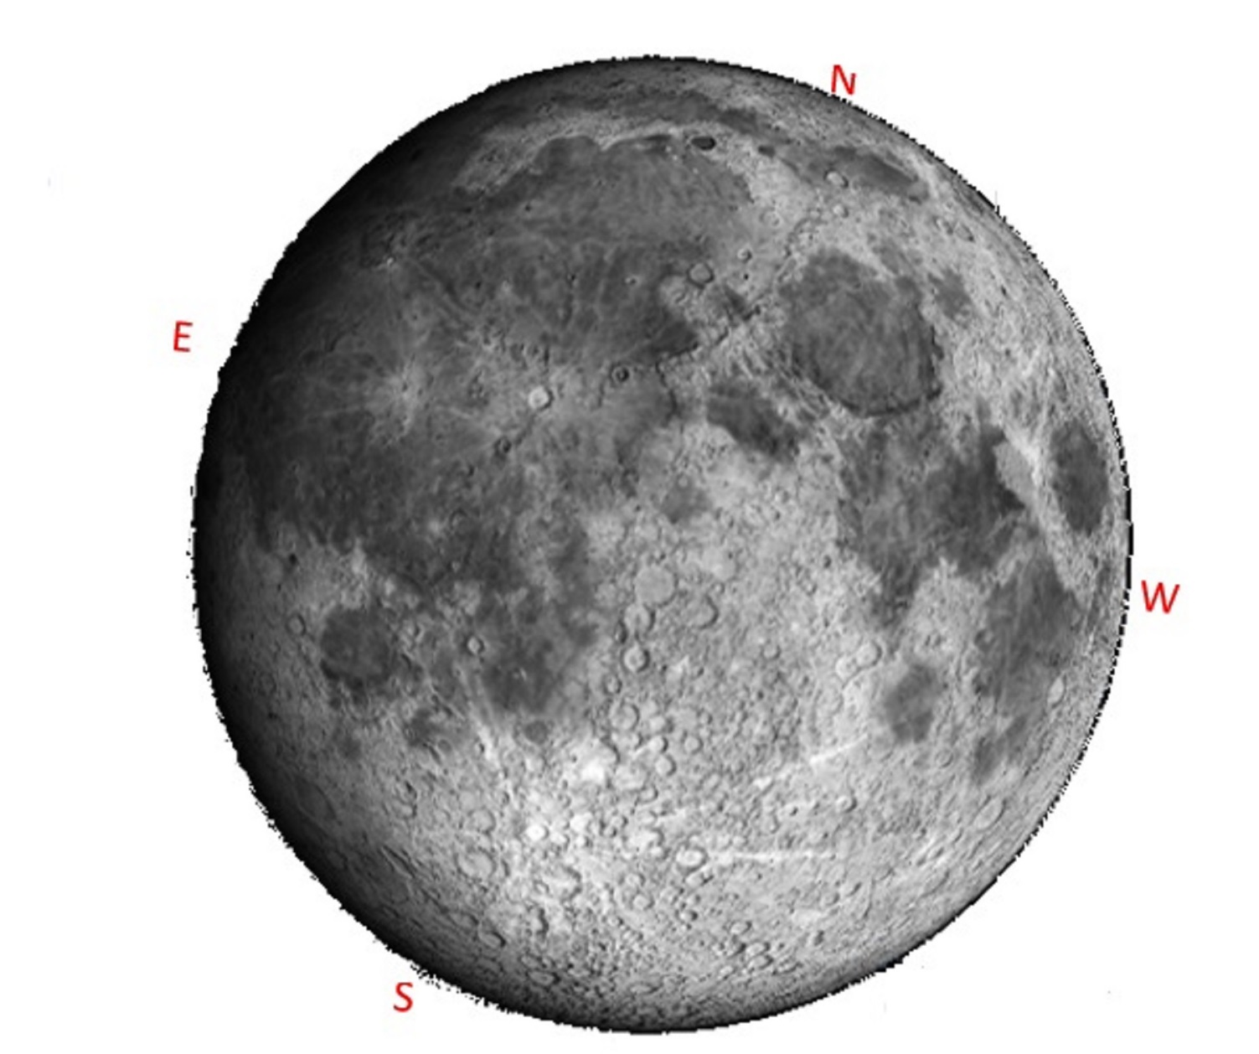

**South Pole**

W

S

**Tycho Crater**